**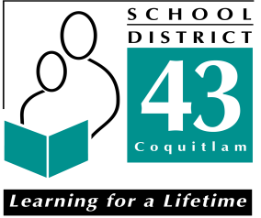高貴林學校局新移民安頓服務項目舉辦免費國語講座**

#### Free Mandarin Workshop Offered by

#### SD43 Settlement Workers in Schools program

**如何準備升讀／申請大學之門**

**How to Prepare and Apply For Universities**

**C:\Documents and Settings\jchen\Local Settings\Temporary Internet Files\Content.IE5\DL6OONI2\MCBD06926_0000[1].wmf**

1. **介紹卑詩省中學生的畢業要求**

**Introduction to the Graduation Program in BC**

1. C:\Documents and Settings\jchen\Local Settings\Temporary Internet Files\Content.IE5\GALUM6BN\MCj04247300000[1].wmf**申請加拿大大學的要求**

**Requirements to Apply for Universities in Canada**

1. C:\Documents and Settings\jchen\Local Settings\Temporary Internet Files\Content.IE5\KLFZG2SD\MCj04241660000[1].wmf**申請美國大學的要求**

**Requirements to Apply for Universities in US**

1. **如何當個快樂的中學生**

**How to Handle Stress in Secondary Schools**

**主講嘉賓： 梁楊彩明 三聯市亞裔家長協會主席**

Speaker： Ms. Salina Leung President of Tri-City Asian Parent Association

**時間: 2011年10月13日 星期四 下午3:30 至 5:00**

Time: October 13th, 2011, Thursday 3:30 – 5:00 p.m.

**地點: 位於1600 King Albert Ave.的Vanier Center** （Poirier图书馆西南）

Location: Gym, Vanier Center (1600 King Albert Ave. Coquitlam V3J 1Y5)

**諮詢或報名（**Inquiries or Registration)：

**Stella Chen:　 604-803-8128, schen@sd43.bc.ca**

**請預先報名及留座.(**Please register before you come. Thank you. **)**